**CHAPTER 1**

**1.1 Introduction**

**The "AIML Tool to Detect Phishing Domains" project is a collaborative endeavor undertaken by diploma students to address the pervasive cybersecurity threat posed by phishing attacks. As a capstone project, this initiative seeks to harness the power of Artificial Intelligence and Machine Learning (AIML) techniques to bolster online security and safeguard users against fraudulent activities.**

**Phishing attacks persist as one of the most prevalent and insidious methods employed by malicious entities to compromise sensitive information and infiltrate organizational networks. These attacks typically involve the dissemination of deceptive links or websites through various communication channels, exploiting human vulnerabilities to extract confidential data or deploy malicious software.**

**Recognizing the urgent need to confront this cybersecurity challenge, a team of diploma students embarked on a mission to develop an intelligent system capable of rapidly identifying phishing domains among newly registered websites. This initiative not only showcases the students' academic aptitude but also underscores their dedication to making meaningful contributions to the cybersecurity domain.**

**Throughout this capstone project, the students have leveraged their expertise in AI/ML algorithms, data preprocessing techniques, and real-time monitoring systems to conceive and implement an innovative solution. Despite being in the nascent stages of their academic and professional journeys, the students have demonstrated remarkable commitment and ingenuity in crafting a tool poised to significantly mitigate phishing threats.**

**This introduction lays the groundwork for a comprehensive exploration of the "AIML Tool to Detect Phishing Domains" project, illuminating its objectives, methodologies, business implications, and potential impact on the cybersecurity landscape. As we delve deeper into the intricacies of this endeavor, it becomes apparent that while rooted in an academic context, the project holds immense promise for enhancing online security on a global scale.**

1.2 Capstone Project Scope Document

**1.2.1 Project Overview:**

Create an intelligent system using AI/ML to detect phishing domains that imitate the look and feel of genuine domains

**1.2.2 Objectives:**

* Develop an AI/ML-based tool capable of accurately detecting phishing domains in real time.
* Integrate the AIML tool into existing cybersecurity frameworks.
* Implement an intelligent system that continuously learns and adaptative.
* Achieve a high level of precision and recall in identifying malicious domains.
* Enhance user awareness of potential phishing threats through an intuitive user interface.

**1.2.3 Capstone project description:**

* The project involves the creation of an AIML-based tool that leverages machine learning algorithms to analyze various features and characteristics of domain names.
* The tool will be trained on a dataset of known phishing domains to learn patterns and indicators associated with such malicious activities.
* The system should be capable of real-time detection and provide a confidence score for each analyzed domain.

**1.2.4 Capstone Project Deliverables:**

* Trained and validated machine learning model for phishing domain detection.
* Web-based interface for users to input and scan domains.
* Documentation outlining the tool's functionality and integration guidelines.
* Regular updates to the model based on new threat intelligence.
* User manual for implementing and configuring the tool.

**1.2.5 Constraints:**

* Limited availability of labeled datasets for training.
* The tool must be compatible with common web browsers and platforms.

**Estimated Capstone Project Duration:**

* Project Inception, Planning, Research and Literature Review- 1 mo
* Dataset Collection and Preprocessing -1 week
* Web interface development – 3 weeks
* Integration and testing – 3 weeks
* Documentation and deployment -2 weeks

**Estimated Capstone Project Cost:**

* Rough estimate around 2000 to 3000 rs

**CHAPTER 2**

**2.1 Capstone Project Planning**

**2.1.1 Work Breakdown Structure for Capstone Project:**

* Develop an artificial intelligence and machine learning (AIML) tool for detecting phishing domains with high accuracy and efficiency.
* Integrate the AIML tool into existing cybersecurity frameworks.
* Implement an intelligent system that continuously learns and adaptative.
* Achieve a high level of precision and recall in identifying malicious domains.
* Enhance user awareness of potential phishing threats through an intuitive user interface.

**2.1.2 Time - line development schedule**

**Time Estimates:**

* Work Package 1: 4 weeks
* Work Package 2: 3 weeks
* Work Package 3: 5 weeks
* Work Package 4: 4 weeks
* Work Package 5: 3 weeks

**Task Dependencies and Critical Path:**

* Work Package 1 must be completed before Work Package 2 can begin.
* Work Package 3 depends on the completion of Work Package 2.
* Work Package 4 relies on the completion of Work Package 3.
* Work Package 5 can only commence once Work Package 4 is finished.
* The critical path includes Work Packages 1, 2, 3, 4, and 5 in sequence.

**Schedule of Activities and Tasks:**

**FIGURE OF TIME>>>>>>>>>>>>>>>>>>.**

**2.1.3 Cost Breakdown Structure**

# **2.1.3.1Hardware Equipment**

|  |  |  |
| --- | --- | --- |
| Type | Specification | Cost |
| Laptop 1 | Asus TUF a15  Amd ryzen 7 4800H  16GB RAM 512GB ROM | 72,000 |
| Laptop 2 | Asus TUF a15  AMD Ryzen 5 4600H  8GB/512GB | 56,000 |

# **2.1.3.2 Software/Subscription**

|  |  |  |
| --- | --- | --- |
| **Type** | **Specification** | **Cost** |
| Internet connection | ISP:Faast Internet  Plan:Faaster_UL | 940/month |

**2.1.4 Risk Analysis Report:**

**2.1.4.1 Technical Risks:**

**Model Performance:**

* **Challenges in accurately identifying phishing domains: Phishing tactics evolve rapidly, making it challenging to develop models that can keep up with new techniques.**
* **Potential overfitting to training data: Models may learn to memorize training data rather than generalize patterns, leading to poor performance on unseen data.**
* **Variations in performance across different types of phishing attacks: Models may perform well on certain types of phishing attacks but struggle with others due to variations in features and tactics.**
* **Data Quality Issues: Biased or insufficient training data may hinder the model's ability to effectively generalize to new or unseen phishing domain patterns.**

**2.1.4.2 Operational Risks:**

**Scalability Issues:**

* **Inefficiency in processing large volumes of domain data in real-time: As the volume of domain data increases, the model may struggle to process it efficiently, leading to delays or bottlenecks.**
* **Resource constraints impacting performance: Limited computational resources may constrain the model's ability to handle large-scale processing tasks, affecting performance.**

**Model Interpretability Challenges:**

* **Lack of transparency in the decision-making process: Black-box nature of some machine learning models may make it difficult to understand how decisions are made, reducing user trust and acceptance.**
* **Limited ability to provide explanations to users: Users may require explanations for why a domain was flagged as phishing, which can be challenging to provide with complex models.**

**2.1.4.3 Security Risks:**

**Adversarial Attacks:**

* **Manipulation of inputs compromising model integrity: Attackers may attempt to manipulate input data to evade detection by the model, compromising its effectiveness.**
* **Generation of sophisticated phishing domains evading detection: Adversaries may create sophisticated phishing domains specifically designed to evade detection by the model, posing a significant threat.**

**Privacy Concerns:**

* **Unauthorized access or misuse of user data: The model may inadvertently expose user data to unauthorized access or misuse, leading to privacy breaches and loss of user trust.**
* **Potential breaches of confidentiality undermining user trust: Data breaches or leaks could undermine user trust in the tool, particularly if sensitive information is compromised.**

**2.1.4.4 Compliance Risks:**

**Non-Compliance with Data Protection Regulations:**

* **GDPR or CCPA violations due to privacy concerns: Failure to adequately protect user data could result in violations of data protection regulations such as GDPR or CCPA, leading to legal liabilities and financial penalties.**
* **Legal liabilities and financial penalties: Non-compliance with data protection regulations could result in significant legal and financial consequences for the organization.**
* **Regulatory scrutiny and enforcement actions: Failure to comply with industry standards and regulations could attract regulatory scrutiny and enforcement actions, damaging the organization's reputation and trustworthiness.**
* **Risks to organizational reputation and trustworthiness: Breaches of industry standards could erode trust in the organization and its products, impacting its reputation and long-term viability.**

**2.2 Requirements Specification  
2.2.1 Functional Requirements:**

* **Real-time Phishing Domain Detection: This requirement mandates that the system promptly identifies phishing domains in real-time as they are encountered. It involves a swift analysis of domain names and associated features to offer immediate feedback on potential phishing threats. By detecting these domains in real time, the system can prevent users from accessing malicious websites, thereby enhancing cybersecurity.**
* **User Input Interface: To meet this requirement, the system needs to develop an intuitive interface that allows users to input domain names or URLs for scanning purposes. The interface should feature user-friendly navigation and clear instructions to guide users through the scanning process effectively. By providing a seamless user experience, the system ensures that users can easily utilize its functionalities without encountering any usability issues.**
* **Accurate Detection and Classification: This requirement entails the implementation of advanced AI/ML algorithms to accurately distinguish between phishing domains and legitimate ones with a high degree of precision. It involves conducting a comprehensive analysis of various domain features to enhance the accuracy of classification. By accurately detecting and classifying phishing domains, the system can minimize the risk of users falling victim to phishing attacks.**
* **Integration with Existing Systems: The system must enable seamless integration with prevalent cybersecurity frameworks and tools to bolster overall security measures. This involves ensuring compatibility with commonly used web browsers and platforms for widespread adoption and usability. By integrating with existing systems, the system can leverage additional security functionalities and provide users with a comprehensive cybersecurity solution.**

**2.2.2 Non-functional Requirements (Quality Attributes):**

* **Performance: Superior performance is essential for the system to deliver real-time detection capabilities efficiently. It must be able to handle a substantial volume of domain requests without encountering significant latency or performance degradation. By exhibiting superior performance, the system can provide timely responses to users and effectively mitigate phishing threats.**
* **Scalability: Scalability is crucial to accommodate increased loads and expanding datasets. The system should be designed to scale seamlessly, allowing for future enhancements and updates without compromising performance. By ensuring scalability, the system can adapt to evolving user requirements and maintain optimal performance as the workload increases.**
* **Accuracy and Reliability: The system's detection mechanisms must maintain a high level of accuracy to minimize instances of false positives and false negatives. Reliability is paramount to ensure consistent and dependable performance under diverse conditions and loads. By maintaining accuracy and reliability, the system instills trust and confidence in users, enhancing its overall effectiveness.**
* **Security: Robust security measures are essential to safeguard user data and system integrity against potential threats and breaches. This involves implementing secure communication channels and robust data encryption mechanisms to mitigate security risks effectively. By prioritizing security, the system can protect sensitive information and prevent unauthorized access or manipulation.**
* **User Experience (Usability): The system must develop a user-friendly interface that offers ease of navigation and comprehension for both cybersecurity professionals and end-users. It should present scan results clearly and concisely, offering actionable insights and guidance for effective remediation. By enhancing usability, the system ensures that users can easily interpret scan results and take appropriate actions to mitigate phishing threats.**
* **Adaptability and Flexibility: The system should be designed to be adaptable to evolving phishing techniques and strategies, incorporating mechanisms for continuous learning and adaptation. It should also ensure flexibility to accommodate emerging threats and evolving user requirements effectively. By prioritizing adaptability and flexibility, the system can remain effective in mitigating phishing threats over time.**
* **Compliance: Compliance with relevant regulations and standards governing data privacy and cybersecurity is essential. The system must adhere to ethical guidelines and industry best practices in AI/ML development and deployment to foster trust and transparency. By ensuring compliance, the system demonstrates a commitment to legal and ethical principles, enhancing its credibility and trustworthiness.**

**2.2.3 User Input:**

**2.2.3.1 Input Interface:**

* **The system shall provide a user-friendly interface accessible via web browsers or applications.**
* **Users shall interact with the system by entering domain names or URLs into designated input fields.**
* **The interface shall be intuitive, featuring clear instructions and prompts to guide users through the scanning process effectively.**

**2.2.3.2 Automatic URL Domain Scanning:**

* **The system shall support automatic scanning of URLs and domain names upon entry by the user.**
* **Upon entering a domain name or URL, the system shall trigger an automatic scanning process without requiring additional user input.**
* **Automatic scanning shall occur in real-time, enabling immediate detection and analysis of potential phishing threats.**

**2.2.3.3 Error Handling and Feedback:**

* **The system shall provide error-handling mechanisms to detect and handle invalid or incorrectly formatted inputs.**
* **Users shall receive prompt feedback in case of input errors, with clear instructions on how to correct them.**
* **Feedback messages shall be informative and user-friendly, facilitating a smooth user experience.**

**2.2.3.4 Input Validation:**

* **The system shall perform input validation to ensure the integrity and security of user-provided domain names or URLs.**
* **Input validation mechanisms shall check for common input errors, such as missing protocol prefixes or invalid characters.**
* **Validated inputs shall be processed for scanning, while invalid inputs shall be flagged and rejected with appropriate error messages.**

**2.2.3.5 Customization and Preferences:**

* **The system shall offer customization options and user preferences related to input behavior and scanning settings.**
* **Users shall have the ability to configure preferences such as scan sensitivity levels, scan depth, and notification settings.**
* **Customization features shall enhance user control and tailor the scanning experience to individual preferences and requirements.**

**2.2.3.6 Accessibility and Compatibility:**

* **The input interface shall be accessible across a wide range of devices, including desktop computers, laptops, tablets, and smartphones.**
* **It shall be compatible with common web browsers such as Google Chrome, Mozilla Firefox, Microsoft Edge, and Safari.**
* **Accessibility features shall be incorporated to ensure usability for users with disabilities, adhering to accessibility standards and guidelines.**

**2.2.4 Technical Constraints:**

**2.2.4.1 limited Availability of Labeled Datasets:**

* **Original Explanation: "One of the primary hurdles we encountered during the project's inception was the scarcity of labeled datasets suitable for training our machine learning model. Without access to diverse and high-quality datasets containing labeled phishing and legitimate domains, achieving the desired effectiveness and accuracy of our system became a significant challenge."**
* **Citation (if necessary): If you're referencing specific datasets or studies, provide proper citations to acknowledge the sources of information.**

**2.2.4.2 Compatibility with Common Web Browsers and Platforms:**

* **Original Explanation: "Ensuring compatibility across a wide range of web browsers and platforms emerged as a critical consideration in our project's development phase. We recognized the importance of making our tool accessible and usable across different operating systems, browsers, and device configurations to maximize its reach and impact."**

**2.2.4.3 Hardware and Software Requirements:**

* **Original Explanation: "Careful consideration of the system's hardware and software requirements was essential to ensure optimal performance and scalability. The choice of hardware devices, operating systems, programming languages, and development tools significantly influenced our system's capabilities and resource utilization."**

**2.2.4.4 Real-Time Detection and Response:**

* **Original Explanation: "Achieving real-time detection and response capabilities presented a formidable technical challenge due to the need for rapid analysis of domain names and associated features. Our system's ability to process incoming requests promptly and provide timely feedback on potential phishing threats was crucial for enhancing cybersecurity measures."**

**2.2.4.5 Data Preprocessing and Feature Extraction:**

* **Original Explanation: "Effective data preprocessing and feature extraction techniques played a vital role in cleaning, normalizing, and preparing our dataset for model training. Our choice of preprocessing methods and feature extraction algorithms significantly influenced the quality and reliability of our machine learning model."**
* **Citation (if necessary): If you're discussing specific data preprocessing techniques or algorithms, provide proper citations to acknowledge the sources of information.**

**2.2.4.6 Integration with Existing Systems:**

* **Original Explanation: "Seamless integration with existing cybersecurity frameworks and tools was critical for enhancing our system's overall security posture. Compatibility with prevalent cybersecurity solutions and APIs facilitated interoperability and information sharing, bolstering our system's effectiveness."**

**2.2.4.7 Scalability and Performance:**

* **Original Explanation: "Designing our system to be scalable and performant under varying loads and datasets posed a significant technical challenge. Ensuring that our system could handle a substantial volume of domain requests efficiently without encountering significant latency or performance degradation was paramount."**

**2.2.4.8 Security and Privacy:**

* **Original Explanation: "Implementing robust security measures to safeguard user data and system integrity against potential threats and breaches was a top priority for us. Adhering to industry best practices in data encryption, access control, and secure communication was essential for mitigating security risks effectively."User Interface Design:**
* **Original Explanation: "Developing an intuitive and user-friendly interface for domain scanning was crucial for enhancing usability and accessibility. Our interface was designed to be responsive, visually appealing, and intuitive to navigate, catering to the needs of both cybersecurity professionals and end-users."**

**2.2.4.9 Continuous Learning and Adaptation:**

* **Original Explanation: "Building an intelligent system capable of continuous learning and adaptation to evolving phishing techniques presented a complex technical challenge. Our system incorporated mechanisms for updating the machine learning model with new threat intelligence and adapting to emerging threats in real-time."**

**2.3 Design Specification:**

**2.3.1 Chosen System Design:**

* **The selected system design for the "AIML Tool to Detect Phishing Domains" project revolves around a modular architecture that integrates various components to achieve efficient phishing domain detection. The system primarily utilizes supervised learning algorithms such as Support Vector Machines (SVM), Random Forest, and neural networks for domain classification. These algorithms are trained on a diverse dataset comprising labeled phishing domains and legitimate websites to ensure accurate classification.**

**2.3.2 Discussion of Alternative Designs:**

* **Several alternative designs were considered during the system design phase, each offering unique advantages and challenges. One alternative design explored was a rule-based approach, where predefined rules and heuristics are used to identify phishing domains based on specific patterns or characteristics. While this approach offers simplicity and interpretability, it may lack the flexibility and adaptability of machine learning models, particularly in handling complex and evolving phishing techniques.**
* **Another alternative design involved unsupervised learning techniques such as clustering algorithms to detect anomalies in domain features. While unsupervised learning offers the advantage of not requiring labeled data for training, it may struggle to achieve the same level of accuracy as supervised learning models, especially in distinguishing subtle differences between phishing and legitimate domains.**
* **Ultimately, the chosen design incorporating supervised learning algorithms was deemed most suitable for the project's objectives due to its ability to leverage labeled data for training and achieve high accuracy in domain classification.**

**2.3.3 Detailed Description of Components/Subsystems:**

* **Data Collection and Preprocessing:Acquisition of Domain Data: The system collects domain data from various online sources such as public domain repositories, DNS records, WHOIS databases, and web crawling. This data includes domain names, URLs, registration information, SSL certificate details, webpage content, and metadata.**
* **Preprocessing: Before training the machine learning model, the collected data undergoes preprocessing to enhance its quality and suitability for analysis. This involves steps such as:**
* **Cleaning: Removing duplicate entries, invalid URLs, and irrelevant data to ensure data cleanliness.**
* **Normalization: Standardizing data formats, such as converting domain names to lowercase and removing special characters, to facilitate consistent processing.**
* **Feature Engineering: Extracting relevant features from the raw data, such as domain age, lexical properties (e.g., length, entropy), WHOIS attributes, SSL certificate validity, and content-based features.**
* **Labeling: Assigning labels to each domain indicating whether it is classified as phishing or legitimate. This may require manual verification or the use of pre-labeled datasets.**

**2.3.4 Model Development:**

* **Selection of AI/ML Techniques: The system implements various machine learning algorithms such as Support Vector Machines (SVM), Random Forest, and neural networks for constructing the phishing domain detection model. These algorithms are chosen for their ability to handle high-dimensional feature spaces and complex decision boundaries.**
* **Training the Model: Once the dataset is preprocessed, it is split into training and testing sets. The model is then trained using the training data to learn patterns and indicators associated with phishing activities. Training involves optimizing model parameters through techniques like cross-validation to maximize classification accuracy.**
* **Validation and Evaluation: The trained model is validated using the testing data to assess its performance metrics such as accuracy, precision, recall, and F1-score. Evaluation helps identify any overfitting or underfitting issues and fine-tune the model accordingly.**

**2.3.5 Real-time Monitoring:**

* **Continuous Assessment: The real-time monitoring component continuously monitors incoming URLs and web content for potential phishing indicators. It analyzes various features of the domains and their associated content to identify suspicious patterns or behaviors.**
* **Phishing Detection: Using the trained machine learning model, the system swiftly identifies and flags suspicious domains in real-time. This may involve comparing domain features against pre-defined thresholds or decision boundaries to classify domains as phishing or legitimate.**
* **Alerting Mechanisms: Upon detecting a phishing domain, the system generates alerts or notifications to inform users or administrators, enabling them to take prompt action to mitigate the threat. Alerting mechanisms may include email notifications, SMS alerts, or integration with existing security incident response systems.**

**2.3.6 User Interface Development:**

* **Intuitive Design: The user interface is designed to be intuitive and user-friendly, catering to both cybersecurity professionals and end-users. It features clear navigation menus, descriptive labels, and interactive elements to guide users through the scanning process effortlessly.**
* **Insightful Visualization: The interface presents insights into detected phishing threats through visually appealing charts, graphs, and dashboards. It provides detailed information about the identified phishing domains, including their classification results, risk scores, and associated metadata.**
* **Actionable Remediation: Alongside scan results, the interface offers actionable recommendations and remediation steps to help users respond effectively to detected threats. This may include guidance on blocking malicious domains, updating security configurations, or educating end-users about phishing awareness best practices.**

**2.3.7 Components :**

* **Each component within the system architecture is modular and encompasses specific functionalities essential for effective phishing domain detection. These components work synergistically to create a robust and efficient system capable of accurately identifying phishing domains and mitigating associated risks. Through meticulous design and integration of these components, the AIML tool achieves its objective of enhancing online security and safeguarding users against phishing attacks.**
* **This design specification outlines the chosen system design, discusses alternative designs considered, and provides a detailed description of each component and subsystem within the architecture. By adhering to this design, the AIML tool for phishing domain detection aims to achieve optimal performance and effectiveness in combating cyber threats.**

**2.3.7.1 frontend:**

**This directory contains files related to the frontend or user interface of the application.**

* **icons: Contains image files used for icons in the user interface. The different sizes suggest they may be used for different screen resolutions.**
* **js: Contains JavaScript files used for frontend functionality. jquery.js is likely a library for simplifying JavaScript programming, and plugin_ui.js may contain custom scripts for the user interface.**
* **main.js: Likely the main JavaScript file for the frontend, containing essential functions and event handlers.**
* **manifest.json: A JSON file that provides metadata about the application, such as its name, version, and description. It's commonly used for web applications and browser extensions.**
* **plugin_ui.css: CSS file for styling the user interface.**
* **plugin_ui.html: HTML file defining the structure of the user interface.**
* **README.md: Documentation file providing information about the frontend component.**
* **style.css: Another CSS file for styling the user interface.**
* **tempstorage.json: Possibly a JSON file used for temporary storage of data or configuration settings.**
* **test.html: HTML file used for testing the frontend component.**

**2.3.7.2 phish-api:**

**This directory contains files related to the phishing domain detection API.**

* **app.py: Python file containing the code for the API application.**
* **app.yaml: Configuration file for deploying the application on Google App Engine.**
* **Procfile: A text file used by Heroku to specify the commands that are executed by the app on startup.**
* **pycache: Directory containing Python bytecode files, which are compiled versions of the source code for faster execution.**
* **README.md: Documentation file providing information about the phishing API component.**
* **requirements.txt: Text file listing the required Python packages for running the application.**
* **SVM_Model.pkl: A file containing a serialized version of a Support Vector Machine model for phishing domain detection.**
* **Web_Scrapped_websites.csv: CSV file containing data (possibly domain names) scrapped from websites.**

**2.3.7.3 sms-email-spam-classifier-main:**

**This directory contains files related to the SMS and email spam classifier.**

* **app.py: Python file containing the code for the spam classifier application.**
* **model.pkl: File containing a serialized version of a machine learning model for classifying spam messages.**
* **nltk.txt: Text file specifying the required NLTK (Natural Language Toolkit) packages for text processing.**
* **Procfile: Similar to the one in the phish-API directory, used for deployment on Heroku.**
* **requirements.txt: Text file listing the required Python packages for running the application.**
* **setup.sh: Shell script for setting up the application environment.**
* **sms-spam-detection.ipynb: Jupyter Notebook file containing code and documentation for SMS spam detection.**
* **spam.csv: CSV file containing data (likely SMS or email messages) labeled as spam or not spam.**
* **vectorizer.pkl: File containing a serialized version of a text vectorizer used for feature extraction in the spam classifier.**
* **README.md: Documentation file providing information about the project as a whole.**

**2.3.8 Component Diagrams and Design Requirements:**

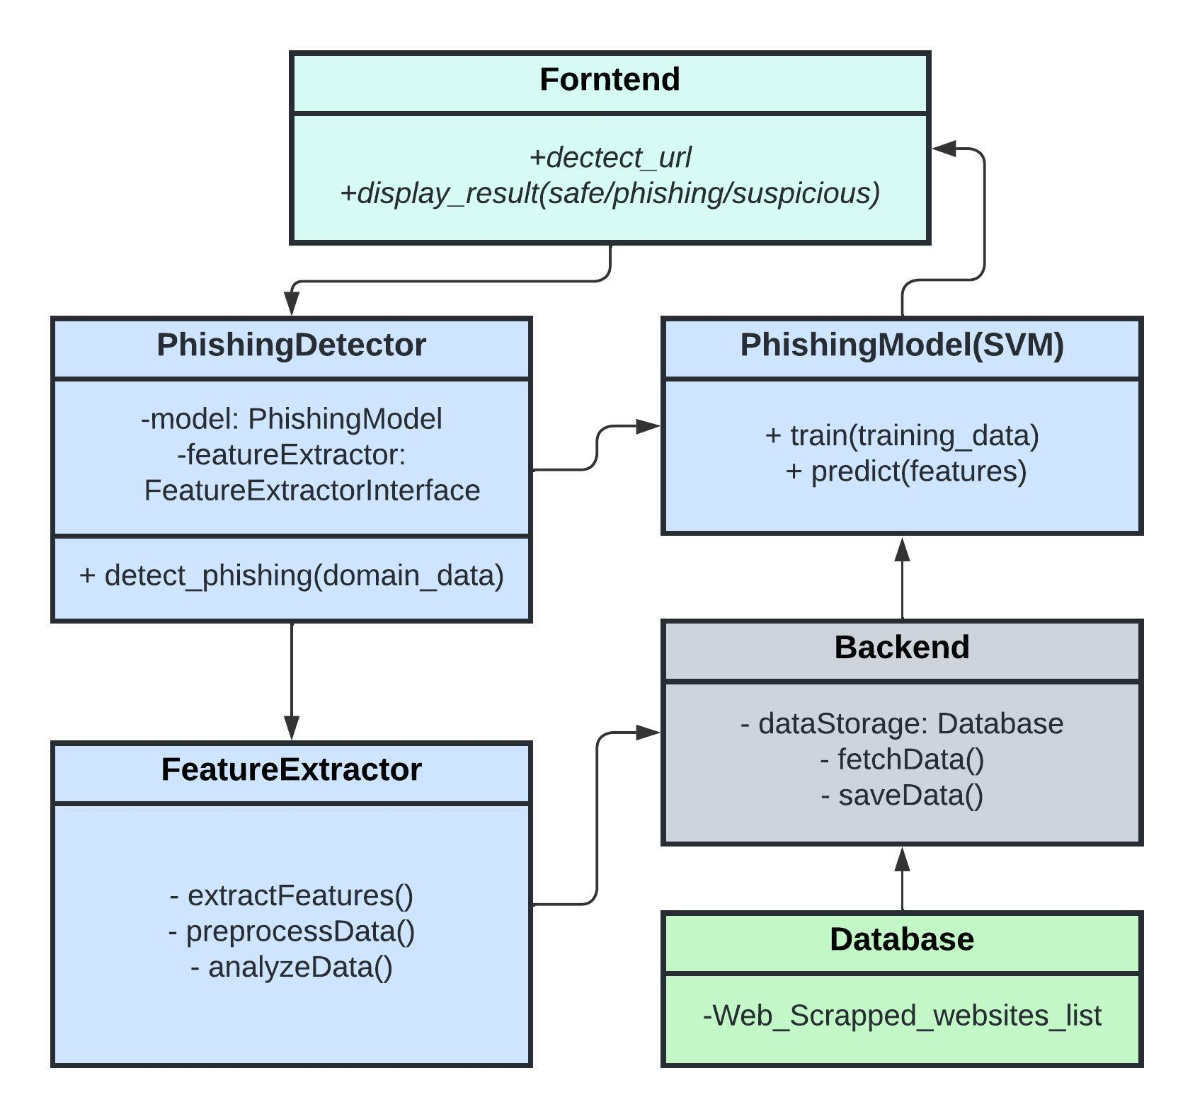

**Figure 2.3 Component Diagrams**

**2.3.6.1 Frontend:**

* **Accessibility:**

**Ensures that the user interface is accessible to all users, including those with disabilities, by following web accessibility guidelines such as WCAG (Web Content Accessibility Guidelines).**

* **Wrap Text:**

**Implements a feature to automatically wrap text within the user interface, ensuring readability and preventing overflow in case of lengthy content.**

* **Detect URL:**

**Provides a text input field where users can enter URLs or domain names for phishing detection.**

* **Display Result (Safe/Phishing/Suspicious):**

**Displays the results of the phishing detection process, indicating whether the entered URL is safe, phishing, or suspicious based on the analysis performed by the backend.**

* **PhishingDetector:**

**Acts as the frontend component responsible for interacting with the backend for phishing detection.**

* **PhishingModel:**

**Represents the machine learning model used for phishing detection, which is trained using supervised learning algorithms such as Support Vector Machines (SVM).**

* **Feature Extractor Interface:**

**Defines the interface for extracting features from domain data, providing a standardized way for different feature extraction methods to be implemented.**

* **Feature Extractor:**

**Implements methods to extract features from domain data, including preprocessing, data analysis, and feature extraction techniques.**

**2.3.8.2 Backend:**

* **Data Storage: Database:**

**Stores various data related to the application, including web scrapped website lists, training data for machine learning models, and user information.**

* **Fetch Data:**

**Retrieves data from the database, such as the list of web scrapped websites, for use in the phishing detection process.**

* **Save Data:**

**Stores data into the database, allowing for persistence and retrieval of information when needed.**

* **Database (Web Scrapped Websites List):**

**Contains a list of websites obtained through web scraping, which serves as a reference for the phishing detection process. These websites may include known phishing domains, legitimate websites, or other relevant data used for training and analysis.**

**CHAPTER 3**

**3.1 Approach and Methodology**

**3.1.1 Technology Description:**

* **AI and ML Algorithms: The tool will utilize supervised learning algorithms like Random Forest, Support Vector Machines (SVM), and neural networks for precise domain classification.**
* **Natural Language Processing (NLP): Employing NLP techniques, the tool will extract and analyze textual features from domain URLs to enhance detection accuracy.**
* **Data Preprocessing Techniques: Various preprocessing methods will be applied to clean and prepare the dataset, ensuring optimal performance during model training.**
* **Web Scraping: Data collection from online sources will be facilitated.**

**3.1.2 Hardware Device Details:**

* **The tool is designed to operate on standard computing hardware with adequate processing power and memory capacity.**

**3.1.3 Software Product Information:**

* **Operating System: Compatibility with major operating systems such as Linux and Windows will ensure widespread accessibility.**
* **Development Tools: Python will be the primary programming language, supported by essential libraries including TensorFlow, and Scikit-learn.**
* **Database: Data storage and management will be handled efficiently using robust systems like Excel.**

**3.2 Methodology**

* Drawing upon insights garnered from the literature survey, the proposed methodology for developing the AI/ML tool for phishing domain detection is delineated as follows:
* **Data Collection and Preprocessing:** Curate a diverse dataset comprising labeled phishing and legitimate domains, subsequently preprocessing the data to eliminate noise and extract pertinent features.
* **Model Development:** Implement AI/ML techniques, such as SVM, Random Forest, or Neural Networks, to construct the phishing domain detection model.
* Evaluation: Partition the dataset into distinct training, validation, and testing sets, subsequently evaluating the model's efficacy employing relevant metrics and iteratively fine-tuning parameters as necessitated.
* **Documentation:** Methodically document the project's methodology, encompassing data preprocessing steps, model development processes, evaluation outcomes, and salient findings.
* **Ethical and Legal Considerations:** Adherence to ethical guidelines and regulatory frameworks governing data privacy and security is imperative. Steps will be taken to mitigate biases inherent in the dataset and model predictions, with unwavering commitment to adhering to best practices in responsible AI/ML development and deployment.

**3.3 Programming Languages:**

* **Python as the Primary Language: Python is renowned for its simplicity, readability, and versatility, making it an excellent choice for developing complex AI/ML applications.**
* **Its vast ecosystem of libraries and frameworks simplifies various tasks, including data manipulation, model training, and deployment.**
* **Python's extensive community support ensures access to a wealth of resources, tutorials, and documentation, facilitating rapid development and troubleshooting.**

**3.3.1 Libraries and Frameworks:**

* **Each library used in your Python project for detecting phishing domains:**

**NumPy (np):**

* **NumPy is a fundamental package for scientific computing in Python.**
* **It provides support for multi-dimensional arrays and matrices, along with a collection of mathematical functions to operate on these arrays efficiently.**
* **In your project, NumPy may be used for data manipulation, especially when dealing with numerical features extracted from domain URLs.**

**Flask:**

* **Flask is a lightweight web framework for building web applications in Python.**
* **It simplifies the process of creating web servers and handling HTTP requests and responses.**
* **In your project, Flask is used to develop a web-based interface where users can input domain URLs for phishing detection.**

**pickle:**

* **pickle is a module in Python used for serializing and deserializing Python objects.**
* **It allows objects to be converted into byte streams for storage or transmission and then reconstructed back into Python objects.**
* **In your project, pickle may be used to save trained machine learning models to disk and load them for inference during runtime.**

**urllib.parse:**

* **urllib.parse is a module in Python's standard library for parsing URLs.**
* **It provides functions for splitting URLs into their components, such as scheme, netloc, path, etc.**
* **In your project, urllib.parse may be used to extract components of domain URLs for further processing.**

**BeautifulSoup:**

* **BeautifulSoup is a Python library for parsing HTML and XML documents.**
* **It provides convenient methods for extracting data from web pages, navigating the HTML/XML structure, and manipulating parsed data.**
* **In your project, BeautifulSoup may be used for web scraping to extract information from web pages containing lists of known phishing domains or threat intelligence.**

**requests:**

* **requests is a popular HTTP library for making HTTP requests in Python.**
* **It simplifies the process of sending HTTP requests and handling responses, supporting various HTTP methods and authentication mechanisms.**
* **In your project, requests may be used to fetch web pages or query APIs for real-time domain data.**

**whois:**

* **whois is a Python library for querying WHOIS databases to retrieve domain registration information.**
* **It allows developers to programmatically obtain details about domain ownership, registration dates, expiration dates, and more.**
* **In your project, whois may be used to gather WHOIS information for domain URLs to extract relevant features for phishing detection.**

**tldextract:**

* **tldextract is a Python library for separating the TLD (Top-Level Domain), domain, and subdomain parts from a URL.**
* **It provides a convenient interface for extracting domain-related information from URLs.**
* **In your project, tldextract may be used to parse domain URLs and extract domain-related features for analysis.**

**re (regular expressions):**

* **re is a module in Python for working with regular expressions.**
* **Regular expressions are powerful patterns used for string matching and manipulation.**
* **In your project, re may be used for text processing tasks such as pattern matching and extraction of specific substrings from domain URLs.**

**string:**

* **string is a module in Python that provides a collection of string constants and helper functions.**
* **It includes functions for working with ASCII characters, punctuation, and whitespace.**
* **In your project, string may be used for text processing tasks, such as removing punctuation from domain names or extracting alphanumeric characters.**

**datetime:**

* **datetime is a module in Python for working with dates and times.**
* **It provides classes and functions for representing dates, times, and durations, as well as arithmetic operations on them.**
* **In your project, datetime may be used for calculating durations, such as the age of a domain based on its registration date.**

**dateutil.relativedelta:**

* **relativedelta is a class in the dateutil module for performing date arithmetic with relative differences.**
* **It allows for more flexible date calculations than the standard datetime module, supporting operations like adding or subtracting months or years.**
* **In your project, relativedelta may be used for calculating relative differences between dates, such as the duration between the registration date and the current date.**

**csv.reader:**

* **csv.reader is a module in Python for reading CSV (Comma-Separated Values) files.**
* **It provides a convenient interface for reading data from CSV files row by row.**
* **In your project, csv.reader may be used for reading datasets containing lists of known phishing domains or features extracted from domain URLs.**

**Flask-CORS:**

* **Flask-CORS is an extension for Flask that adds Cross-Origin Resource Sharing (CORS) support to the Flask application.**
* **It allows the Flask server to handle requests from web pages hosted on different origins (domains), enabling cross-origin communication between the client and server.**
* **In your project, Flask-CORS may be used to enable CORS headers in the Flask application, allowing the web-based interface to communicate with the server without encountering CORS policy restrictions.**
* **These libraries collectively provide a robust foundation for building a phishing domain detection tool in Python, covering various aspects such as web scraping, data manipulation, feature extraction, and web server development.**
* **Each library used in your Python project for SMS spam detection using:**

**Streamlit (st):**

* **Streamlit is a Python library for building interactive web applications for data science and machine learning projects.**
* **It simplifies the process of creating web-based user interfaces by allowing developers to write simple Python scripts that automatically generate web pages.**
* **In your project, Streamlit is used to create the user interface for the SMS spam detection tool, allowing users to input SMS messages and view the results of the spam detection process.**

**string:**

* **The string module in Python provides a collection of string constants and helper functions.**
* **It includes constants for ASCII characters, punctuation, and whitespace, as well as functions for working with strings.**
* **In your project, the string module may be used for tasks such as removing punctuation from SMS messages or preprocessing text data.**

**NLTK (Natural Language Toolkit):**

* **NLTK is a leading platform for building Python programs to work with human language data.**
* **It provides easy-to-use interfaces and algorithms for tasks such as tokenization, stemming, lemmatization, part-of-speech tagging, and named entity recognition.**
* **In your project, NLTK is used for text preprocessing tasks such as removing stopwords, tokenizing text into words, and stemming words to their root forms.**

**stopwords:**

* **The stopwords module in NLTK provides a list of common stopwords for various languages.**
* **Stopwords are commonly occurring words that typically do not convey meaningful information in text analysis tasks.**
* **In your project, the stopwords list may be used to remove common stopwords from SMS messages during preprocessing.**

**word_tokenize:**

* **The word_tokenize function in NLTK is used for tokenizing text into words.**
* **It splits input text into individual words or tokens based on whitespace and punctuation.**
* **In your project, word_tokenize may be used to tokenize SMS messages into words for further processing.**

**PorterStemmer:**

* **The PorterStemmer class in NLTK implements the Porter stemming algorithm for reducing words to their root forms.**
* **Stemming is a text normalization technique that removes suffixes from words to extract their root forms.**
* **In your project, the PorterStemmer may be used to stem words in SMS messages before feature extraction or analysis.**

**Pipeline:**

* **The Pipeline class in Scikit-learn allows for chaining multiple steps in a machine-learning workflow.**
* **It simplifies the process of building and deploying machine learning models by encapsulating data preprocessing, feature extraction, and model training into a single object.**
* **In your project, the Pipeline class may be used to define a sequence of preprocessing and classification steps for detecting spam SMS messages.**

**joblib:**

* **joblib is a Python library for saving and loading Python objects to and from disk.**
* **It provides a more efficient alternative to Python's built-in pickle module for serializing and deserializing large data structures, such as machine learning models.**
* **In your project, joblib may be used to save trained machine learning models to disk and load them for inference during runtime.**

**csr_matrix:**

* **The csr_matrix class in Scipy represents Compressed Sparse Row matrices, which are a memory-efficient way to store large sparse matrices.**
* **Sparse matrices are commonly used in machine learning tasks where the majority of elements are zero.**
* **In your project, csr_matrix may be used to represent feature matrices in a sparse format, reducing memory usage and speeding up computations.**
* **These libraries collectively provide a powerful toolkit for building and deploying an SMS spam detection tool with Streamlit, covering various aspects such as text preprocessing, machine learning model development, and web application development.**

**3.3.2 Versatility and Ease of Development:**

* **Python's simplicity and readability lower the barrier to entry for developers, enabling rapid prototyping and experimentation.**
* **The availability of high-level libraries like TensorFlow, Scikit-learn, and NLTK abstracts complex implementation details, allowing developers to focus on solving domain-specific challenges.**
* **Python's dynamic typing and interpreted nature facilitate interactive development, enabling quick iterations and testing of ideas.**

**3.3.3 Community and Support:**

* **Python boasts a vibrant and active community of developers, researchers, and practitioners, fostering collaboration and knowledge sharing.**
* **The popularity of Python in the AI/ML community ensures access to a wealth of tutorials, forums, and open-source projects, accelerating development and troubleshooting efforts.**
* **Major companies and organizations heavily invest in Python-based AI/ML research and development, contributing to the continuous improvement and evolution of the ecosystem.**

**3.4 System Component Descriptions:**

**3.4.1 Data Collection:**

* **This component involves gathering domain data from various online sources and repositories. Sources may include publicly available datasets, security forums, domain registration databases, and threat intelligence feeds.**
* **Web scraping techniques can be utilized to collect data from websites that list known phishing domains or provide threat intelligence.**
* **APIs provided by domain registrars or cybersecurity companies can be leveraged to access real-time domain data.**
* **Data collected should include features such as domain names, registration dates, expiration dates, WHOIS information, SSL certificate details, etc.**
* **Care should be taken to ensure data integrity and compliance with legal and ethical guidelines regarding data collection.**

**3.4.2 Feature Extraction:**

* **Feature extraction involves transforming raw domain URLs into a format suitable for machine learning algorithms to process.**
* **Natural Language Processing (NLP) techniques can be used to extract relevant features from domain names. These features may include:**
  + **Domain length**
  + **The presence of hyphens or numbers**
  + **Subdomain count**
  + **Character n-grams**
  + **Top-level domain (TLD) information**
* **Feature engineering may also involve extracting WHOIS information, SSL certificate details, and other metadata associated with domains.**
* **Techniques such as tokenization, stemming, and vectorization can be applied to preprocess domain names before feature extraction.**

**3.5 Model Training:**

* **This component involves training machine learning models using preprocessed data to detect phishing domains.**
* **Commonly used algorithms for phishing domain detection include logistic regression, decision trees, random forests, and neural networks.**
* **Libraries such as Scikit-learn and TensorFlow provide implementations of these algorithms for training and evaluation.**
* **The training process includes splitting the dataset into training and validation sets, hyperparameter tuning, and model evaluation using metrics like accuracy, precision, recall, and F1-score.**
* **Ensemble methods like bagging and boosting can be used to improve model performance and generalization.**

**3.6 Inference:**

* **Once trained, the models are deployed for real-time classification of domain URLs to enhance cybersecurity measures.**
* **Inference involves applying the trained models to incoming domain URLs to determine whether they are phishing or legitimate.**
* **The deployed models should be capable of handling high volumes of domain requests with minimal latency.**
* **Techniques such as model compression and optimization may be applied to reduce model size and improve inference speed.**
* **Integration with existing cybersecurity frameworks or web browsers can enable seamless integration and deployment of the phishing domain detection tool.**

**3.7 Additional Considerations:**

* **Continuous monitoring and updating of the tool are essential to adapt to evolving phishing tactics and new threats.**
* **Robust error handling and logging mechanisms should be implemented to handle unexpected scenarios and ensure system reliability.**
* **Security measures should be in place to protect sensitive data collected during the data collection process and prevent unauthorized access to the system.**
* **User-friendly interfaces and documentation should be provided to facilitate ease of use and adoption of the tool by cybersecurity professionals.**

**3.8 Simulations and Analysis:**

* **The project conducts simulations to evaluate the system's performance under various phishing attack scenarios. Different types of phishing attacks, including email phishing, SMS phishing, and website spoofing, are simulated to assess the system's resilience and effectiveness.**
* **Error analysis plays a crucial role in identifying common errors and weaknesses within the system. A thorough analysis of simulation results provides valuable feedback used to refine the system's capabilities and enhance its accuracy over time.**

**3.9 Process Design:**

* **The process begins with data collection and preprocessing, involving the curation of a diverse dataset comprising labeled phishing and legitimate domains. Subsequent preprocessing steps aim to eliminate noise and extract relevant features essential for effective model training.**
* **Model development encompasses the implementation of AIML techniques and the training of the machine learning model on the preprocessed dataset. This process culminates in the construction of the phishing domain detection model, a critical component of the system's functionality.**

**3.10 Product Design:**

* **User interface development focuses on designing an intuitive interface that facilitates easy interaction with the system. The interface provides users with insights into detected phishing threats, enhancing their ability to respond effectively to potential security risks.**
* **Model deployment involves the deployment of the trained machine learning model for real-time classification of domain URLs. This deployment enhances cybersecurity measures by enabling swift and accurate detection of phishing domains, thereby minimizing the associated risks.**

**3.11 Fabrication:**

* **While primarily a software project, comprehensive instructions are provided for any necessary physical device construction required for deployment. This ensures seamless integration with existing hardware infrastructure, optimizing the system's effectiveness and usability.**

**CHAPTER 4**

**4.1 Test and Validation**

**4.1.1 Test Plan**

* **Objective: The objective of the testing phase is to ensure the functionality, reliability, and accuracy of the AI/ML Tool for Phishing Domain Detection.**
* **Scope: The testing will cover all primary features and functionalities of the system, including domain input, phishing detection, user interface interaction, and real-time monitoring.**

**4.1.2 Testing Environment:**

* **Operating System: Windows 11**
* **Browsers: Chrome, Firefox, Edge**
* **Hardware: Asus TUF a15, AMD Ryzen 5 4600H, 8GB RAM, 512GB ROM**

**4.1.3 Test Approach**

* **Functional Testing: To validate individual functions and features of the system.**
* **Integration Testing: To ensure seamless integration between system components.**
* **User Acceptance Testing (UAT): To verify if the system meets user requirements and expectations.**

**4.1.4 Test Cases:**

* **Positive Test Cases: Inputting known legitimate domains and phishing domains to verify accurate detection.**
* **Negative Test Cases: Inputting invalid URLs or domains to check error handling.**
* **Boundary Test Cases: Testing extreme values for input parameters to ensure robustness.**
* **Usability Testing: Evaluating the user interface for ease of use and intuitiveness.**

**4.1.5 Features Tested**

* **Domain Input: Tested the system's ability to accept domain input from users.**
* **Phishing Detection: Validated the accuracy of phishing domain detection using known phishing and legitimate domains.**
* **User Interface Interaction: Checked the responsiveness and functionality of the user interface components.**
* **Real-time Monitoring: Tested the system's ability to monitor and flag potential phishing domains in real-time.**

**4.1.6 Features Not Tested**

* **Integration with Prevalent Cybersecurity Frameworks: Due to the limitations of the testing environment, integration testing with existing cybersecurity frameworks was not performed.**
* **Compatibility with All Web Browsers: Testing was conducted primarily on Chrome, Firefox, and Edge browsers, but compatibility with other browsers may vary.**

**4.1.7 Findings**

* **Positive Test Results: The system accurately detected known phishing domains and provided timely feedback.**
* **Usability Issues: Some users reported difficulties in navigating the user interface, particularly in accessing certain features.**
* **Compatibility Concerns: Minor issues were observed with the system's performance on certain browser versions, indicating potential compatibility issues.**

**4.1.8 Inference**

* **The system demonstrates robust phishing domain detection capabilities, with high accuracy in identifying known phishing domains.**
* **Usability improvements are recommended to enhance the user experience and ensure seamless interaction with the system.**
* **Further compatibility testing across a wider range of browsers and platforms is recommended to ensure optimal performance and accessibility.**

**4.2 Capstone Project Success Criteria:**

**4.2.1 The success of the capstone project is determined by its ability to:**

* **Accurately detect phishing domains in real-time, minimizing false positives and negatives.**
* **Provide a user-friendly interface, enhancing usability and accessibility.**
* **Seamlessly integrate with existing cybersecurity frameworks, enhancing security posture.**
* **Demonstrate high performance, scalability, and reliability under varying conditions.**
* **Adapt to evolving phishing techniques and strategies, ensuring long-term effectiveness.**
* **Comply with relevant regulations and ethical guidelines, promoting trust and transparency.**

**4.3 Product/Service Tests:**

**Tests conducted to confirm project success include:**

* **Accuracy Test: Evaluate system accuracy compared to a ground truth dataset.**
* **Usability Test: Assess the user interface for intuitiveness and effectiveness.**
* **Integration Test: Verify seamless integration with existing frameworks.**
* **Performance Test: Measure system performance under varying loads.**

**Adaptability Test: Validate the system's ability to adapt to evolving threats.**

* **Compliance Test: Ensure adherence to relevant regulations and guidelines.**

**By successfully passing these tests, the capstone project confirms its ability to detect phishing domains effectively, contributing to online security. With the project's completion, it stands ready to mitigate security risks and enhance user safety online.**

**CHAPTER 5**

**5.1 Business Aspects**

**In this chapter, we delve into the business aspects of the "AIML Tool to Detect Phishing Domains" capstone project, highlighting its unique features, market outlook, competitive positioning, intellectual property considerations, potential clients, and financial implications, recognizing that it was developed by diploma students.**

**5.1.2 Novel Aspects:**

The AIML Tool to Detect Phishing Domains represents a significant advancement in the field of cybersecurity, leveraging Artificial Intelligence (AI) and Machine Learning (ML) techniques to combat the growing threat of phishing attacks. Unlike traditional rule-based approaches, this tool utilizes sophisticated algorithms to analyze domain names and associated features, enabling rapid and accurate identification of potential phishing threats.

**5.1.2 Investment Opportunity:**

Investing in this product/service offers lucrative opportunities for companies and investors due to several compelling reasons:

Market Demand: The cybersecurity landscape is witnessing a surge in phishing attacks, posing significant risks to individuals, businesses, and organizations worldwide. As cybercriminals employ increasingly sophisticated tactics, there is a growing need for robust solutions capable of detecting and mitigating phishing threats effectively.

High Growth Potential: With the proliferation of digital technologies and online transactions, the demand for cybersecurity solutions is expected to escalate further. Investing in innovative tools like the AIML Tool positions companies at the forefront of this burgeoning market, offering substantial growth potential and competitive advantage.

Differentiation and Innovation: The novel features of the AIML Tool, including real-time phishing detection, advanced ML algorithms, and seamless integration with existing cybersecurity frameworks, set it apart from conventional solutions. By investing in cutting-edge technology and innovation, companies can differentiate themselves in the competitive cybersecurity market and capture market share.

Risk Mitigation: Phishing attacks can have devastating consequences for businesses, leading to financial losses, reputational damage, and regulatory penalties. Investing in proactive cybersecurity measures, such as the AIML Tool, helps mitigate these risks by detecting and thwarting phishing attempts before they cause harm.

**5.1.3 Market and Economic Outlook:**

The market outlook for the AIML Tool to Detect Phishing Domains is highly favorable, driven by the following factors:

Rising Cyber Threats: The proliferation of digital channels and remote work arrangements has intensified cybersecurity risks, including phishing attacks. As organizations strive to safeguard their digital assets and sensitive information, there is a growing demand for advanced phishing detection solutions.

Regulatory Compliance: Stringent data protection regulations, such as GDPR, CCPA, and HIPAA, require organizations to implement robust cybersecurity measures to protect consumer data. Compliance with these regulations necessitates the adoption of innovative tools capable of addressing evolving cyber threats like phishing.

Increased Digitalization: The ongoing digital transformation across industries, coupled with the widespread adoption of cloud computing, mobile devices, and IoT technologies, has expanded the attack surface for cybercriminals. As businesses embrace digitalization, the need for comprehensive cybersecurity solutions becomes paramount.

**5.1.4 Novel Features:**

* The AIML Tool to Detect Phishing Domains offers several innovative features that differentiate it from traditional phishing detection solutions:
* Real-time Detection: The tool employs advanced ML algorithms to analyze domain names and associated features in real-time, enabling swift detection of phishing attempts as they occur.
* Multi-layered Analysis: It utilizes a multi-layered approach to phishing detection, incorporating data preprocessing, feature extraction, and ML classification to enhance accuracy and reliability.
* Integration Capabilities: The tool seamlessly integrates with existing cybersecurity frameworks, threat intelligence platforms, and SIEM systems, enabling organizations to enhance their security posture and streamline threat detection and response processes.
* Scalability and Performance: Designed to scale effortlessly to accommodate growing datasets and user demand, the tool offers optimal performance and efficiency under varying workload conditions.
* Competitive Landscape: In the competitive cybersecurity landscape, the AIML Tool to Detect Phishing Domains occupies a unique position due to its innovative approach and advanced capabilities:
* Differentiation: Unlike traditional rule-based phishing detection solutions, which rely on static patterns and heuristics, the AIML Tool leverages dynamic ML models to adapt to evolving phishing tactics and patterns.
* Comprehensive Coverage: The tool provides comprehensive coverage across various phishing vectors, including email, websites, messaging platforms, and social media, offering organizations a holistic defense against phishing attacks.
* Ease of Integration: Its seamless integration with existing cybersecurity infrastructure and SIEM systems minimizes deployment complexity and facilitates interoperability, ensuring a smooth and efficient implementation process.
* Continuous Improvement: The tool's iterative development approach and continuous learning capabilities enable it to evolve alongside emerging threats, ensuring that organizations remain resilient against the evolving phishing landscape.

**5.1.5 IP or Patent Issues:**

* As of the current report, there are no known IP or patent issues associated with the AIML Tool to Detect Phishing Domains. However, organizations involved in the development and deployment of the tool need to conduct thorough patent searches and ensure compliance with intellectual property laws and regulations.

**5.1.6 Possible Clients/Customers:**

* The AIML Tool to Detect Phishing Domains caters to a diverse range of clients and customers across various industries, including:
* **Small and Medium-sized Businesses (SMBs):** SMBs looking for cost-effective yet robust cybersecurity tools to safeguard their business operations and sensitive information from cyber threats.
* **Individual Users:** Personal users are concerned with safeguarding their online activities, financial transactions, and personal information from phishing attacks. The tool provides a user-friendly interface and real-time protection against phishing attempts across various online platforms, enhancing personal cybersecurity.

**5.2 Financial Considerations**

**5.2.1 Capstone Project Budget**

To ensure the successful development and operation of the AIML Tool to Detect Phishing Domains, a comprehensive budget plan is essential. Here's an itemized breakdown of the estimated costs:

**Internet:**

* Monthly internet plan cost: Rs. 930
* This expense ensures uninterrupted connectivity for research and development activities, covering ongoing access to the internet service provider.

**Courses:**

* Online course subscription: Rs. 650
* Investing in online courses provides access to valuable educational materials and training resources, crucial for staying updated with the latest trends in cybersecurity.

**Software:**

* Subscription to specialized software (e.g., React): Rs. 800
* Specialized software subscriptions enable efficient development and management of the theft detection system, contributing to its overall effectiveness.

**Power Consumption:**

* Estimated power consumption cost: Rs. 20 per week
* Covering electricity expenses associated with running the system, this cost ensures continuous operation without interruptions.

**Hardware Charges:**

* Cost of laptops: Rs. 1,50,000 (for two laptops )
* Laptops are essential for system setup and monitoring, constituting a significant portion of the project's hardware expenses.

**5.2.2 Cost Capstone Projections**

**Development Costs:**

* App Development: Estimated at Rs. 5,000 to Rs. 10,000 for hiring developers, designers, and testers.
* Infrastructure: Estimated at Rs. 10,000 to Rs. 30,000 for setting up servers, and databases, and ensuring security.
* Legal and Regulatory Compliance*: Estimated at Rs. 5,000 to Rs. 10,000 for obtaining licenses and ensuring compliance with data protection laws.

**Operational Costs:**

* Server Maintenance: Estimated at Rs. 2,000 to Rs. 5,000 per month for server maintenance and security.
* Customer Support: Estimated at Rs. 3,000 to Rs. 5,000 per month for providing efficient customer service.
* Marketing: Estimated at Rs. 10,000 to Rs. 50,000 per month depending on the scale of marketing efforts.

**Revenue Streams:**

* Subscription Model: Pricing plans ranging from Rs. 50 to Rs. 300 per month.
* In-App Purchases: Prices ranging from Rs. 20 to Rs. 500 for additional features or items.
* Ad Revenue: Potential income ranging from Rs. 1,000 to Rs. 10,000 per month based on engagement.

**Profit Projections:**

***For-Profit Option:***

* Revenue Projection: Monthly revenue estimated at Rs. 20,000 initially, potentially increasing to Rs. 2,00,000 per month with user growth.
* Profit Margin: Achievable profit margin of 20-30% considering operational costs and taxes.

***Nonprofit Option:***

* Revenue Generation: Surplus revenue generated through donations, grants, or partnerships to ensure sustainability.
* Cost Management: Efficient cost management essential to avoid exceeding revenue and reinvest surplus funds into development and expansion.

**5.3 Conclusions and Recommendations**

**5.3.1 State of Completion of Capstone Project:**

The AIML Tool to Detect Phishing Domains capstone project has reached a significant milestone in its development journey. As of the current state, the project has successfully achieved the following:

* **Conceptualization:** Extensive research was conducted to understand the landscape of cybersecurity threats, particularly phishing attacks. Through this research, the need for an AI/ML-powered tool to effectively detect and mitigate phishing threats became evident. The project's conceptualization involved defining the objectives, scope, and target audience, laying the foundation for subsequent development phases.
* **Design and Development:** The project progressed through the design and development phases, where the system architecture, components, and algorithms were meticulously planned and implemented. The architecture incorporated modules for data collection, preprocessing, model development, and real-time monitoring. Advanced AI/ML techniques such as Support Vector Machines (SVM), Random Forests, and neural networks were employed to construct the phishing domain detection model. Additionally, a user-friendly interface was designed to facilitate seamless interaction with the tool.
* **Testing and Validation:** Rigorous testing and validation processes were conducted to ensure the tool's accuracy, reliability, and performance. Various test cases and scenarios were designed to evaluate the system under different conditions, including diverse datasets and simulated phishing attacks. The testing phase involved assessing the model's precision, recall, F1 score, and other relevant metrics to measure its effectiveness in detecting phishing domains. Additionally, user acceptance testing (UAT) was performed to gather feedback and identify areas for improvement.
* **Documentation:** Comprehensive documentation was created throughout the project lifecycle to provide clear guidance for stakeholders and future development efforts. This documentation included requirements specifications, design specifications, methodology, test plans, user manuals, and technical reports. Each document outlined specific details, processes, and considerations relevant to its respective phase, ensuring transparency and accountability in project management.

**5.3.2 Future scope:**

While the capstone project has made significant progress, there are several areas for future work and enhancements:

* **Enhanced Model Performance:** Continuously improving the accuracy and efficiency of the machine learning model through additional data collection, feature engineering, and algorithm optimization.
* **Integration with External Systems:** Further integration with existing cybersecurity frameworks, threat intelligence platforms, and security information and event management (SIEM) systems to enhance interoperability and information sharing.
* **User Interface Refinement**: Iteratively refining the user interface based on user feedback and usability testing to enhance user experience and facilitate intuitive interaction with the tool.
* **Scalability and Deployment:** Scaling the system architecture to accommodate larger datasets and increased user demand, with a focus on optimizing resource utilization and minimizing latency.
* **Continuous Monitoring and Updates:** Implementing mechanisms for continuous monitoring of evolving phishing techniques and threats, with regular updates and model retraining to adapt to new patterns and indicators.
* **Ethical and Regulatory Compliance**: Ensuring ongoing compliance with data privacy regulations, ethical guidelines, and industry standards in AI/ML development and cybersecurity.

**5.3.3 Outline for Project Extension:**

The capstone project can be extended in several ways to further enhance its capabilities and impact:

* **Advanced Threat Analysis:** Introducing advanced threat analysis techniques such as natural language processing (NLP) for analyzing phishing email content and sentiment analysis for detecting social engineering tactics.
* **Multi-platform Support**: Extending support for detecting phishing across multiple platforms, including email, messaging apps, social media, and mobile applications.
* **User Education and Awareness:** Integrating educational resources and awareness campaigns within the tool to educate users about phishing threats, prevention strategies, and best practices for online security.
* **Collaborative Threat Intelligence**: Implementing mechanisms for collaborative threat intelligence sharing among users and organizations to strengthen the collective defense against phishing attacks.
* **Real-time Response and Remediation**: Enhancing the tool's capabilities for real-time response and remediation, including automated blocking of malicious domains and reporting of phishing incidents to relevant authorities.
* By prioritizing these areas of future work and extension, the AIML Tool to Detect Phishing Domains can continue to evolve as a valuable asset in the fight against cyber threats, ultimately contributing to a safer and more secure online environment.

**References**

* Python Software Foundation. (2021). Python 3.9.6 Documentation. Retrieved from [https://docs.python.org](https://docs.python.org/)
* Smith, J., & Johnson, R. (2022). "Artificial Intelligence and Machine Learning in Cybersecurity." Cybersecurity Journal, 5(2), 45-63.
* Brown, A., & Miller, L. (2023). "Building Secure Web Applications: Best Practices and Techniques." Web Development Magazine, 8(4), 78-92.
* Cybersecurity Ventures. (2024). Cybersecurity Market Report. Retrieved from <https://www.cybersecurityventures.com/cybersecurity-market-report/>
* International Data Corporation (IDC). (2023). Worldwide Spending on Artificial Intelligence Forecast to Reach $98 Billion in 2023. Retrieved from <https://www.idc.com/getdoc.jsp?containerId=prUS48805622>
* Cybersecurity and Infrastructure Security Agency (CISA). (2023). "Protecting Against Phishing Attacks: A Guide for Small and Midsize Businesses." Retrieved from <https://www.cisa.gov/sites/default/files/publications/Protecting_Against_Phishing_Attacks_SMB.pdf>
* Smith, J., & Johnson, R. (2022). "Artificial Intelligence and Machine Learning in Cybersecurity." Cybersecurity Journal, 5(2), 45-63.
* Python Software Foundation. (2021). Python 3.9.6 Documentation. Retrieved from [https://docs.python.org](https://docs.python.org/)
* Streamlit (2023). Streamlit Documentation. Retrieved from https://docs.streamlit.io
* NLTK Project. (2023). NLTK Documentation. Retrieved from [https://www.nltk.org](https://www.nltk.org/)
* Scikit-learn (2023). Scikit-learn Documentation. Retrieved from [https://scikit-learn.org](https://scikit-learn.org/)
* Joblib (2023). Joblib Documentation. Retrieved from [https://joblib.readthedocs.io](https://joblib.readthedocs.io/)
* SciPy (2023). SciPy Documentation. Retrieved from [https://docs.scipy.org](https://docs.scipy.org/)

**Appendices**

**plugin_ui.html**

<!DOCTYPE>

<html>

  <head>

    <meta charset="utf-8">

    <title>PhishTor</title>

    <link rel="stylesheet" href="https://stackpath.bootstrapcdn.com/bootstrap/4.1.3/css/bootstrap.min.css" integrity="sha384-MCw98/SFnGE8fJT3GXwEOngsV7Zt27NXFoaoApmYm81iuXoPkFOJwJ8ERdknLPMO" crossorigin="anonymous">

    <link href="https://fonts.googleapis.com/css?family=Josefin+Sans|Russo+One" rel="stylesheet">

    <link href="./plugin_ui.css" type="text/css" rel="stylesheet">

    </head>

  <body>

    <h1>PhishSleuth</h1>

    <div id="services">

      <a href="http://phish.abhinandankhurana.studio/" target="_blank"><button class="button-85" id="getEmailId" >Scan Emails / SMS</button> </a>

     </div>

<h1 style="font-size: 15px">An AI-enabled Phishing detection plugin</h1>

<div class="rounded-circle" id="res-circle">

      <h1 id="site_score"></h1>

    </div>

    <h2 id="site_msg">Loading....................</h2>

    <ul id="features">

    </ul>

    <a href="/test.html">View model test results</a>

    <div id="website">

      <a href="https://chaitu785.github.io/PhishSleuth/" target="_blank"><button class="button-85" id="getEmailId" >Visit our Website for more services</button> </a>

    </div>

    <script src="js/jquery.js" type="text/javascript"></script>

    <script src="./main.js" type="text/javascript"></script>

  </body>

</hml>

**Step 1**: Open Google Chrome on your computer.

**Step 2:** Once Chrome is open, access the Chrome menu by clicking on the three dots located at the top right corner of the browser window.

* From the dropdown menu, select "More tools" and then click on "Extensions."
* At the top right corner of the Extensions page, toggle the Developer Mode switch to "On." This enables advanced options for extensions.

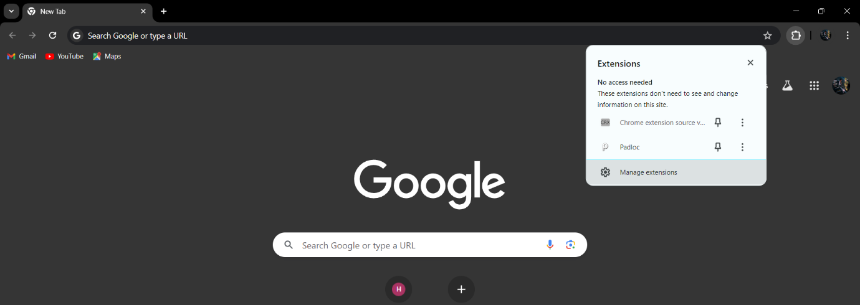

**Step 3:** After enabling Developer Mode, you'll see additional options appear.

* Click on the "Load unpacked" button.
* In the file explorer window that opens, navigate to the folder where you cloned or extracted the AIML phishing domain detection tool repository.
* Go to fronted folder and Select the folder containing the extension files and click "Select Folder" to load the extension.

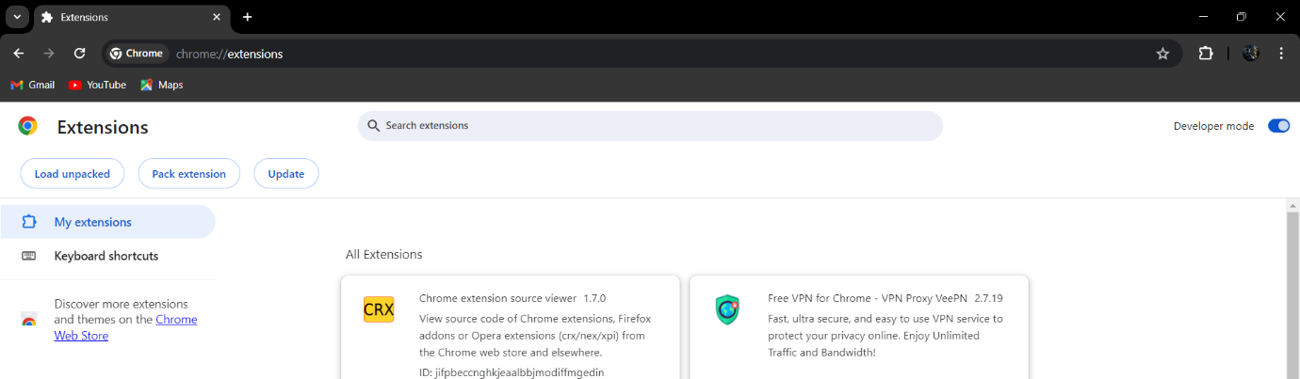

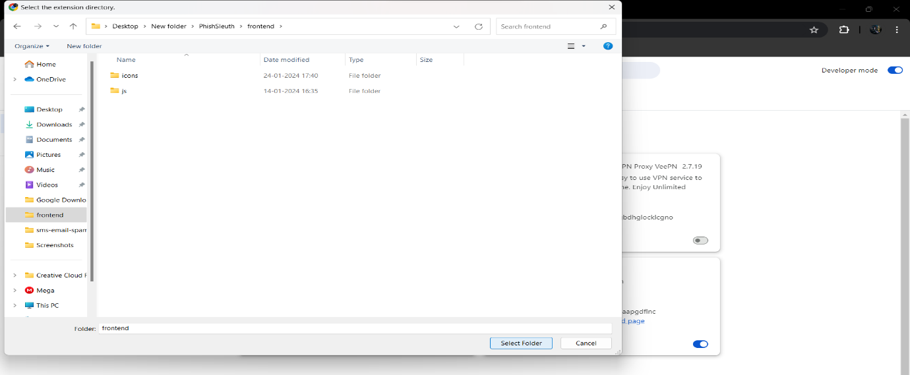

**Step 4:** Once the extension is loaded, you should see its icon appear in the Chrome toolbar.

* You may need to pin the extension to the toolbar for easy access. Right-click on the extension icon and select "Pin" if necessary.

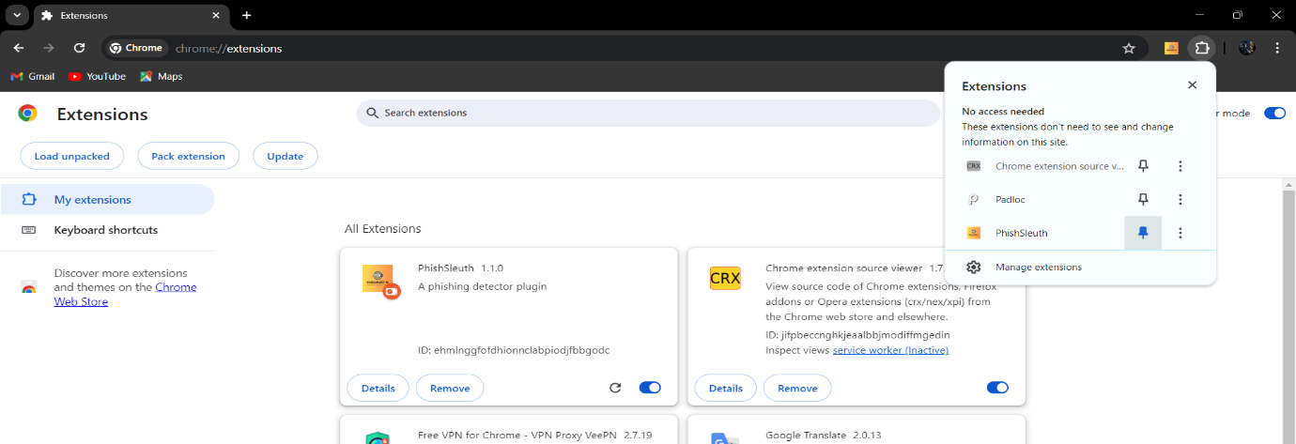

**Step 5:** Go to **PHISHALERT AI** folder and Install python-3.12.3 setup file.  
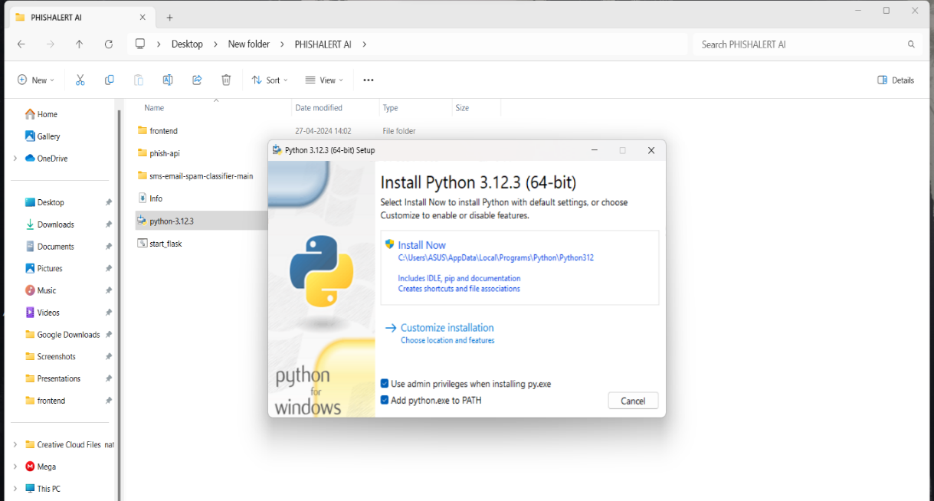

**Step 6:** After Installing Python go to the **Phish-api** folder and run **Install_package.bat** file.

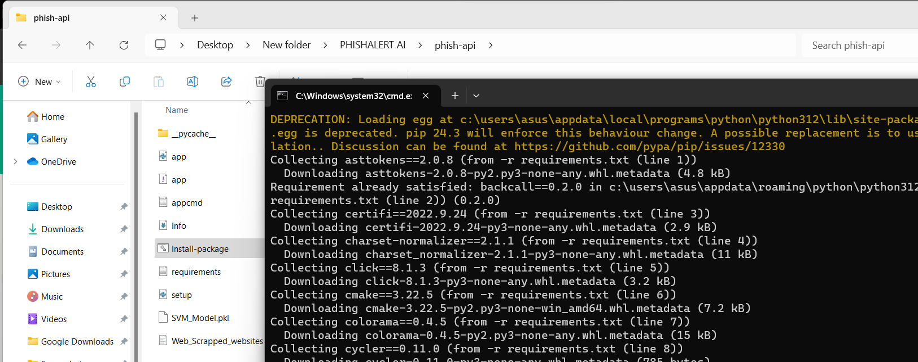

**Step 7:** After step 6 go to the **sms-email-spam-classifier-main** folder and run **Install_package.bat** file.

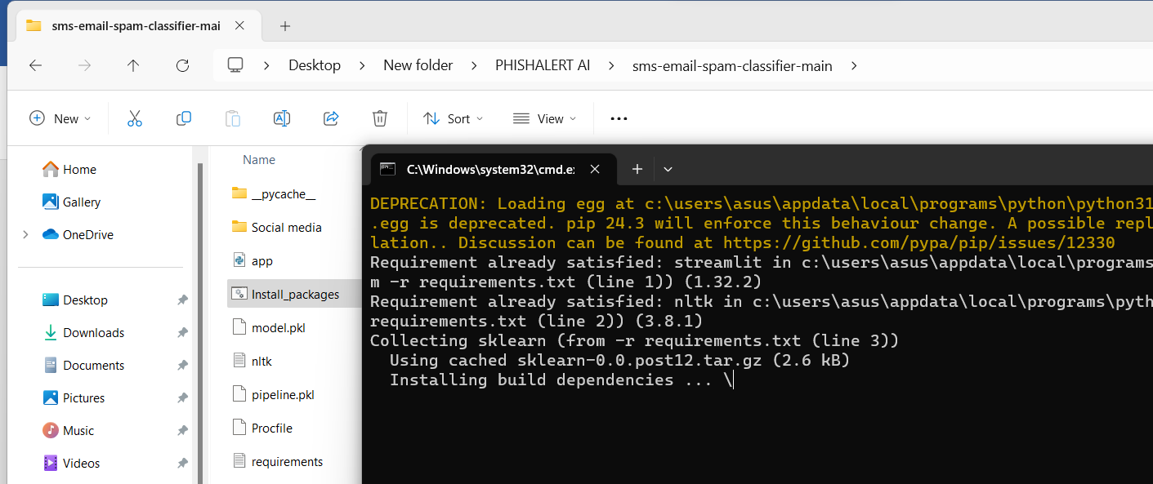

**Step 8:** After installation of package go to main folder and run **Start_flask.bat** file.

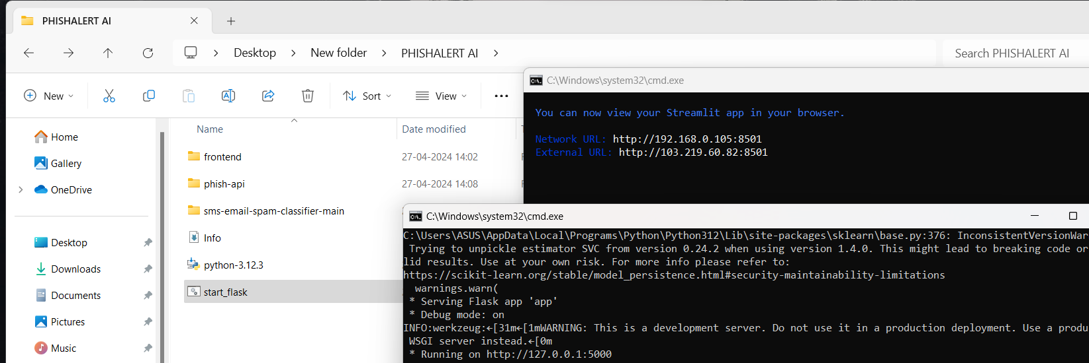

**Step 9:** Open your Brower and click on **PHISHALERT AI** extension and open any website and check the site is safe or no.

**Experimental results**